Decorrelation of Humidity and temperature in chemical sensors for continuous monitoring

Decorellation of humidity and temperature in chemcial sensors for continious monitoring

A project report for decorrelation of humidity and temperature in chemical sensors for continuous monitoring submitted in partial

fulfillment of the requirements for the degree of

Master of Computer Science

By

Devish Mundra

Jawaharlal Nehru Technological University Hyderabad, 2016

Bachelor of Science. in Computer Science

MAY 2016

ABSTRACT

A method for online decorrelation of chemical sensor readings from the effects of environmental humidity and temperature variations is proposed. The goal is to improve the accuracy of electronic nose measurements for continuous monitoring by processing data from simultaneous readings of environmental humidity and temperature. The electronic nose setup built for this study included eight different metal-oxide sensors, temperature and humidity sensors with a wireless communication link to PC. This wireless electronic nose was used to monitor air for two years in the residence and collected data continuously during 510 full days with a sampling rate of 2 samples per second. To estimate the effects of variations in air humidity and temperature on the chemical sensor’s readings, we used a standard energy band model for an n-type metal-oxide sensor. The main assumption of the model is that variations in sensor conductivity can be expressed as a nonlinear function of changes in the semiconductor energy bands in the presence of external humidity and temperature variations. Fitting this model to the collected data, we confirmed that the most statistically significant factors are humidity changes and correlated changes of temperature and humidity. This simple model achieves excellent accuracy with R2 performance close to 1. To show how the humidity-temperature correction model works for gas discrimination, we also collected 100 samples of wine and banana. The goal is to distinguish between wine, banana, and baseline. We show that pattern recognition algorithms improve performance and reliability by including the filtered signal of the chemical sensors.

©2019 by Devish Mundra

All Rights Reserved

TABLE OF CONTENTS

1. Introduction (Word style: Heading 1) 1

1.1 Problem (Word style: Heading 2) 1

1.2 Project Report Statement (alternatively Objective) 1

1.3 Approach 3

1.4 Organization of this Project Report 3

2. Background 5

2.1 Key Concepts 5

3. Architecture 7

3.1 Wireless Electronic Nose Setup 7

3.2 Algothirum Definition 8

4. Expermental Evaluations 9

4.1 Methodology 9

4.2 Results 10

5. Conclusions 13

5.1 Summary 13

References 14

LIST OF FIGURES

Figure 1: Illustrative example of one full day of recordings 3

Figure 2: Electronic nose made of the sensor board 7

Figure 3: Neural Network Architecture 10

Figure 4: ANN Loss Graph during Traning 11

Figure 5: Confusion Matrix 12

# 1. Introduction (Word style: Heading 1)

The following is one way to organize your Project Report. It is by no means the only way but it provides a useful template.

## 1.1 Problem (Word style: Heading 2)

Conductometric chemical sensors are known to be very sensitive to humidity levels in the environment [1, 2, 3, 4, 5, 6, 7, 8, 9, 10, 11]. This sensitivity challenges the tasks of identification and quantification of volatiles in uncontrolled scenarios. For example, electronic noses can be used for human monitoring purposes [12, 13, 14, 15, 16, 17]. They have been successfully used to quantify the number of people working in a space-craft simulator [18]. It is likely that the primary signal used by the algorithm to estimate the number of people present at some given time is the humidity levels in the chamber. If we filter the sensor responses by the humidity and temperature changes, a clearer chemical signature of the chamber can be obtained, and this can facilitate more complex monitoring tasks like detecting individuals. A possible solution to this sensitivity problem is a design of a special sensing chamber that controls humidity and delivers the gas to the sensors under predefined conditions [19, 20, 21, 18, 8]. Such preconditioning chambers are effective for signal improvement, but their use increases the costs of electronic nose design for applications in continuous monitoring of the environment [14]. A different approach is to build a model that predicts the changes in the sensor conductance as a function of humidity and temperature variations [5, 8, 22, 23].

## 1.2 Project Statement (alternatively Objective)

The prevailing phenomenological model of sensor sensitivity is that the ratio of the sensor resistance depends on a power law of the gas concentration [24]. The model provides accurate predictions when the gas is known and under controlled conditions. However, it is rendered inaccurate with changes in the environment. Correction methods based on artificial neural networks [8] using present and past values of the input features are proven to be successful, can capture the dynamical changes of resistance under humidity variations accurately [22]. The number of parameters is not large, but the model parameters depend on the gas presented to the sensors. In continuous monitoring systems, there can be a complex mixture of gases present in the air. Thus, it is indeed challenging to make proper corrections on the sensor readings based on humidity and temperature variations.

## 1.3 Approach

The electronic nose in this setup utilizes 8 metal oxide (MOX) sensors and temperature and humidity sensors. Such platform was previously used in our wind tunnel studies to identify 10 gases at different locations [25]. As a result of this previous investigation, we know that we can discriminate between gases accurately, and estimate gas concentrations in the ppm range [26]. A fragment of recordings presented in Fig. 1 were obtained in October 2014 in a regular working day, in the residence of one of the authors. The top panel shows the humidity levels throughout a complete day where the x-axis indicates the hour of the day. For example, the first rise in humidity at about 5:30AM corresponds to the morning shower. The sudden drop in humidity at about 6:30 AM indicates opening the bathroom window, and the change observed at 5PM is associated with the moment at which the family came back and the door to the backyard was opened. The second panel presents the temperature of the electronic nose location that we denote by TE to differentiate it from the temperature of the sensor heater, T. This residence did not have any air conditioning system or heater operating during this period. One can see from this graph that the environmental changes in humidity and temperature in some time intervals are correlated, while in other intervals are not correlated. The resistance values of the MOX sensors are presented in the four bottom panels. Although the sensor board is made of 8 MOX sensors, here we present recordings of only 4 of them because the remaining sensors are highly correlated with the shown ones. The resistance plots show that humidity and temperature changes strongly affect the resistance of the sensors as expected from the extensive literature on the topic [1, 2, 3, 4, 5, 6, 7, 8, 9, 10, 11]. Nevertheless, the data include also MOX sensor variations that are not a result of the humidity or TE variations. Our goal is to subtract the humidity and temperature driven changes from the MOX sensor responses, and demonstrate that pattern recognition 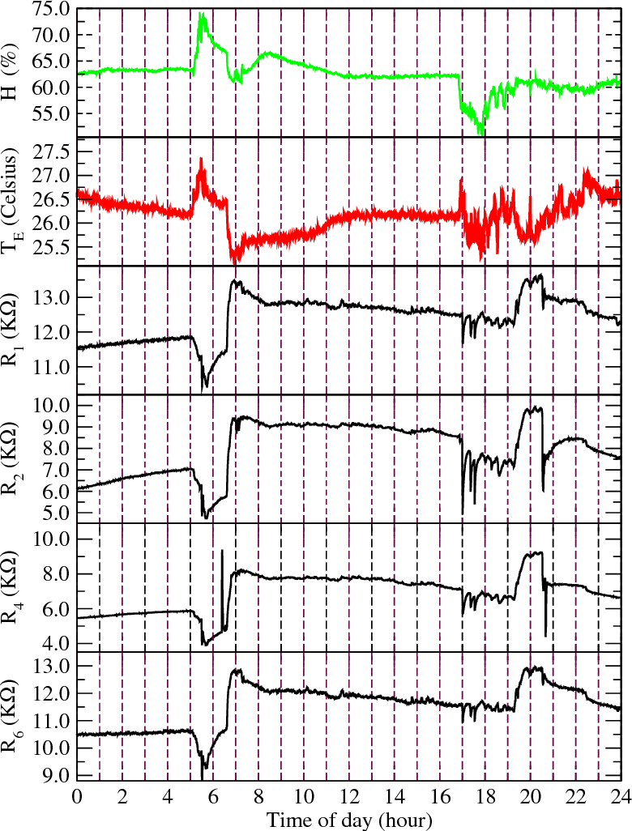algorithms benefit from this operation augmenting its ability to discriminate

**Figure 1: Illustrative example of one full day of recordings using the wireless electronic nose made of 8 MOX sensors including a humidity and temperature sensor. The first panel presents the humidity values, the second panel is the external temperature, and then resistance values for 4 different MOX sensors in the board. The x-axis is the hour of the day for a total of 24 hours**.

different chemical signatures. We test it by creating a dataset of wine and banana and solve the problem of identifying whether the sensor signal was banana, wine or baseline. This is a crucial task for any electronic nose system if one wants to characterize or detect events based on their chemical signatures in the presence of varying environmental conditions.

## 1.4 Organization of this Project Report

The paper starts with the section explaining the model used in our method, followed by the description of the wireless electronic nose used in experiments and the main section presenting the results. In the results section, we analyze the relationship of the parameters of the model fit to the data with the energy band model. Then, we analyze the stability of the parameters over time to determine how long the time window of the data is necessary. We also analyze the maximum sampling period to collect data from the electronic nose to be able to correct for humidity and temperature changes.

# 2. Background

## 2.1 Key Concepts

An energy band model for n-type semiconductors describes the changes in the resistance of the sensor before exposure, RI , and after exposure, RF , as a nonlinear expression of the changes in the semiconductor’s energy bands [1, 2]. Energy bands changes depend on variations in humidity and gas external temperature, which modulates the overall transduction. If we denote by ∆Φ = ΦF − ΦI the work function change computed as the difference between the work function after and before exposure, and we express the electron affinity change as ∆χ = χF − χI , the overall transduction can be expressed (following [2]) as:

ln ( RF/ RI ) = 1 /kBT (∆Φ − ∆χ), (1)

where kB is the Boltzman constant, and T is the sensor operating temperature controlled by the built-in sensor heater. The sensor temperature is not constant because it is modulated by the external temperature, TE. To be able to build a basic model to be fitted to the data, we make the following assumptions. We will assume that relative changes in the external humidity, ∆H = h, and changes in external temperature, ∆TE = t, are small enough. We will also assume that during the environmental changes the chemical content remains unchanged. This is important because it is known that humidity changes induce nonlinear changes in the energy depending on the chemical agent (see [4]). Under these assumptions, we can rewrite the transduction equation 1 as

ln (RF/ RI) = 1/ kB(T + µt) * (∆Φ(h) − ∆χ(h)), (2)

where µ is a dimensionless factor that reflects the impact of the external temperature into the sensor. The sensor board based on the Texas Instruments MSP430F247 micro-controller can apply simple mathematical operations, so we want to make the corrections as linear as possible (see Fig. 2 in the following section). Thus, we apply a series expansion up to order 2 to avoid oversimplification:

ln (RF/ RI) = (1 /kBT – (µ/ kBT2) t + (µ2 /kBT3) t2 + O(t3) )×

( ∆Φ(0) − ∆χ(0) + [ ∂∆Φ /∂h **|** h=0 − ∂∆χ /∂h**|** h=0 ]h + 1/2 [∂2∆Φ / ∂h2|h=0 − ∂2∆χ/∂h2 |h=0 ] h2 + O(h3 ) ) . (3)

Note that ∆Φ(0) − ∆χ(0) = 0 because there are not changes in humidity and temperature on our sampling time scale. Then, we can simplify Equation (3) by considering terms up to order 2, assuming that the sampling period is small enough retaining the terms h i · t j , with i + j ≤ 2. In the results section, we will investigate the validity of this approximation. The simplified model is

ln (RF /RI) = 1 /kBT [∂∆Φ/ ∂h|h=0 − ∂∆χ /∂h|h=0 ] h + 1/2kBT [∂2∆Φ/ ∂h2|h=0 − ∂2∆χ /∂h2 |h=0 ] h2 − µ /kBT2 [ ∂∆Φ /∂h|h=0 − ∂∆χ /∂h|h=0 ]ht . (4)

Therefore, we fit the following model to the data

ln (RF/ RI ) = β1∆H + β2 (∆H)2 + β3∆H∆TE, (5)

|  |  |  |
| --- | --- | --- |
| Sensor type | Number of units | Target gases |
| TGS2611 | 1 | Methane |
| TGS2612 | 1 | Methane, Propane, Butane |
| TGS2610 | 1 | Propane |
| TGS2600 | 1 | Hydrogen, Carbon Monoxide |
| TGS2602 | 2 | Ammonia, H2S, Volatile Organic Compounds (VOC) |
| TGS2620 | 2 | Carbon Monoxide, combustible gases, VOC |

**Table 1: Sensor devices selected for the wireless electronic nose (provided by Figaro Inc.)**

# 3. Architecture

## 3.1 Wireless Electronic Nose Setup

In this section, we describe the electronic nose designed for home monitoring purposes. The sensor array is based on eight metal oxide gas sensors provided by Figaro Inc. The sensors are based on six different sensitive surfaces, which are selected to enhance the system selectivity and sensitivity. Table 1 shows the selected sensing elements along with the corresponding target compounds. In order to control the variability between the sensing elements and increase the flexibility of the sensing platform, the operating temperature of the sensors can be adjusted by applying a voltage to the built-in, independently reachable heating element available in each sensor. The humidity and temperature sensors are integrated in the board using the Sensirion SHT75. The device is very similar to the M-Pod [23], except that ours is directly powered by any electrical outlet to record continuously over long periods of time. The sensor array is integrated with a customized board that includes a microprocessor MSP430F247 (Texas Instruments Inc.). In Fig. 2 we show the operating electronic nose. The microcontroller was programmed to perform the following actions: i) Continuous data collection from the eight chemical sensors through a 12-bit resolution analog-to-digital converter (ADC) device at a sampling rate of 100 Hz; ii) Control of the sensor heater temperature by means of 10 ms period and 6 V amplitude Pulse-Width-Modulated (PWM) driving signals; iii) A two-way communication with another device to transmit the acquired data from the sensors and control the voltage in.

Figure 2: The electronic nose made of the sensor board (right) and a wireless communication board

the sensors’ heaters. The sensor board provides serial data communication to another device via either a USB and/or a 4-pin connector (Tx, Rx, Gnd, Vcc). A wireless communication module acts as a bridge between the MSP430F247 microcontroller and the network. The communication with the MSP430F247 microcontroller is done via the UART port, whereas the communication with the network is performed wirelessly. The board is based on a WiFly RN-131G radio module included in a RN-134 SuRF board (Roving Networks Inc). The WiFly module incorporates a 2.4GHz radio, processor, full TCP/IP stack, real-time clock, FTP, DHCP, DNS and web server. The module can be accessed via a RS-232 serial port (9600 default baud rate) or a 802.11 wireless network so that its configuration can be modified. The wireless communication module is configured such that it accepts UDP and TCP connections, the baudrate of the microprocessor is set to 115200 so that it can exchange data with the MSP430F247 microcontroller, and working with an external 4” reverse polarity antenna to increase the power of the transmission.

## 3.2 Algorithum Definition

We are currently using Keras to build our Artificial Neural Network using Tenser flow in the background for keras. The reason why we chose ANN was to fit the context our problem, since this is a classification problem that allows to learn on each possibility focusing in current observations and predict the next observation where the sensor need to detect different types of gas by decorrelating the environmental temperature and humidity

An example of our algorithm in our python script starts by reading data in our zip file, a file that holds all our sensor observations made during the experiment. The ANN model builds, and the next step is to separate our features from the target data respectively in X and y and then use these two data sets to fit for our ANN model. Once the model is done training, we begin testing the said training data on the test data make predictions.

# 4. Experimental Evaluation

## 4.1 Methodology

For a basic idea of how a deep learning neural network learns, imagine a factory line. After the raw materials (the data set) are input, they are then passed down the conveyer belt, with each subsequent stop or layer extracting a different set of high-level features. If the network is intended to recognize an object, the first layer might analyze the brightness of its pixels.

The next layer could then identify any edges in the image, based on lines of similar pixels. After this, another layer may recognize textures and shapes, and so on. By the time the fourth or fifth layer is reached, the deep learning net will have created complex feature detectors. It can figure out that certain image elements (such as a pair of eyes, a nose, and a mouth) are commonly found together.

Once this is done, the researchers who have trained the network can give labels to the output, and then use backpropagation to correct any mistakes which have been made. After a while, the network can carry out its own classification tasks without needing humans to help every time.

We are currently using two methods to evaluate our method of training. One how well does the ANN or Logistic Regression model predict the best results given a set of information of a time of observations; this would mean that if the target is banana, the best prediction is to make is banana rather than wine. Second, we have a live runtime to show user how well the algorithm can predict the gas. Our hypothesis would be “If given a simple observation of the gas sensors, then a learning model that can learn from the previous observations should provide good decisions for the next observation to maximize goal output”.

**Figure 3: The Neural Network Architecture**

Figure3 explains the basic architecture of the neural network. In this case the three are eleven input layers with three hidden layers and three output layers. The input layer takes eleven inputs such as time, R1, R2, R2, R4 R5, R6, R7, R8, temperature and humidity. There are three hidden layers, the first hidden layer consists of six neurons with tanh as an activation function, the second hidden layer consists of four neurons with tanh as an activation function, and the third hidden layer consists of three neurons with tanh has an activation function. The out layer consists of three neurons with sigmoid as an activation function.

## 4.2 Results

In the neural networks, the loss is usually negative log-likelihood and residual sum of squares for classification and regression respectively. The main objective of the learning model is to reduce the loss function value with respect to the model’s parameters by changing the weight vector values through different optimization methods, such as backpropagation in neural networks.

Loss value implies how well or poorly a certain model behaves after each iteration of optimization. Ideally, one would expect the reduction of loss after each, or several, iteration. In our case we can see the loss which has been gradually decreasing.  As shown below is the ANN loss graph during training.

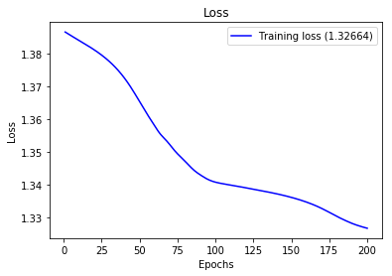

**Figure4: ANN loss graph during training**

The accuracy of a model is usually determined after the model parameters are learned and fixed and no learning is taking place. Then the test samples are fed to the model and the number of mistakes the model makes are recorded, after comparison to the true targets. Then the percentage of misclassification is calculated.  In other words, we show a real runtime representation of how well the model predicts the different gases (in our case wine banana, background).

In the filed of machine learning and specifically the problem of statistical classification, a confusion matrix, also known as error matrix. A confusion matrix is a table that is often used to describe the performance of a classification model on a set of test data for which the true values are known. It allows the visualization of the performance of the algorithm. It allows easy identification of confusion between classes e.g. one class is commonly mislabeled as the other. Most performance measures are computed from the confusion matrix.

The number of correct and incorrect prediction are summarized with count values and broken down by each class. This is the key to confusion matrix. It gives us insight not only into errors being made by a classifier but the types of errors that are being made.

**Figure 5: Confusion Matrix from the experimental results.**

Figure 5 give us the information about the confusion matrix from the experiment. Here we can see that that the model has performed well with a trainset set accuracy of 81.23 and test set accuracy of 82.20. We can cross verify with the result of confusion matrix. It can be observed from that figure that the ANN model was able to classify different gas of banana, wine and background. We can see that positives for banana wine and background are more compared to the negatives.

# 5. Conclusions

## 5.1 Summary

We used an energy band semiconductor model to express the nonlinear dependence of sensor resistance variations in an electronic nose. We found that the most dominant terms are the change in humidity, the quadratic term of the change in humidity, and the correlated variations of humidity and temperature. We showed that the model provides robust corrections to the distortions caused by environmental changes. The coefficients of determination obtained are very close to 1. The model predicts a dependence between two of the coefficients that is consistently verified in all the tested sensors. It is another verification that the approximations 11 used on the semiconductor energy band model are appropriate and an inexpensive solution for applications in continuous chemical monitoring. However, further work is still needed to consider highly ventilated scenarios in which temperature and humidity change at the same constant times than the atmosphere chemical composition.

In order to empirically test the benefits of the humidity-temperature decorrelation model when applied to gas discrimination of the electronic nose, we built artificial neural network to automatically detect banana, wine, and baseline in a home. Experimental results show that including the filtered data in the classification model improves not only the discrimination capability of the model, but, most importantly, its stability.

In summary, we have shown that electronic noses require simultaneous recordings of the humidity and the temperature to be able to isolate more relevant chemical components. Our contribution here intends to emphasize that humidity and temperature need to be simultaneously recorded and that they can be computationally embedded in sensor boards using inexpensive micro-controllers.

# References

[1] N. Barsan, U. Weimar, Conduction model of metal oxide gas sensors, Journal of Electroceramics 7 (3) (2001) 143–167.

[2] N. Barsan, U. Weimar, Understanding the fundamental principles of metal oxide based gas sensors; the example of co sensing with sno2 sensors in the presence of humidity, Journal of Physics: Condensed Matter 15 (20) (2003) R813.

[3] M. Hubner, C. Simion, A. Tomescu-Stanoiu, S. Pokhrel, N. Brsan, U. Weimar, Influence of humidity on {CO} sensing with p-type cuo thick film gas sensors, Sensors and Actuators B: Chemical 153 (2) (2011) 347 – 353.

[4] J. Morante, Chemical to electrical transduction mechanisms from single metal oxide nanowire measurements: response time constant analysis, Nanotechnology 24 (44) (2013) 444004. 12

[5] M. G. Buehler, M. A. Ryan, Temperature and humidity dependence of a polymer-based gas sensor, in: AeroSense’97, International Society for Optics and Photonics, 1997, pp. 40–48.

[6] N. Yamazoe, Toward innovations of gas sensor technology, Sensors and Actuators B: Chemical 108 (1) (2005) 2–14.

[7] A.-C. Romain, J. Nicolas, P. Andre, In situ measurement of olfactive pollution with inorganic semiconductors: Limitations due to humidity and temperature influence, in: Seminars in Food analysis, Vol. 2, 1997, pp. 283–296.

[8] F. Hossein-Babaei, V. Ghafarinia, Compensation for the drift-like terms caused by environmental fluctuations in the responses of chemoresistive gas sensors, Sensors and Actuators B: Chemical 143 (2) (2010) 641–648.

[9] G. F. Fine, L. M. Cavanagh, A. Afonja, R. Binions, Metal oxide semi-conductor gas sensors in environmental monitoring, Sensors 10 (6) (2010) 5469–5502.

[10] A. Oprea, J. Courbat, N. Bˆarsan, D. Briand, N. De Rooij, U. Weimar, Temperature, humidity and gas sensors integrated on plastic foil for low power applications, Sensors and Actuators B: Chemical 140 (1) (2009) 227–232.

[11] C. Wang, L. Yin, L. Zhang, D. Xiang, R. Gao, Metal oxide gas sensors: sensitivity and influencing factors, Sensors 10 (3) (2010) 2088–2106.

[12] A.-C. Romain, D. Godefroid, M. Kuske, J. Nicolas, Monitoring the exhaust air of a compost pile as a process variable with an e-nose, Sensors and Actuators B: Chemical 106 (1) (2005) 29–35.

[13] A.-C. Romain, J. Delva, J. Nicolas, Complementary approaches to measure environmental odours emitted by landfill areas, Sensors and Actuators B: Chemical 131 (1) (2008) 18–23.

[14] W. Bourgeois, A.-C. Romain, J. Nicolas, R. M. Stuetz, The use of sensor arrays for environmental monitoring: interests and limitations, J. Environ. Monit. 5 (2003) 852–860.

[15] M. Ogawa, T. Togawa, monitoring daily activities and behaviors at home by using brief sensors, in: Microtechnologies in Medicine and Biology, 1st Annual International, Conference On. 2000, IEEE, 2000, pp. 611–614.

[16] T. Oyabu, H. Nanto, T. Onodera, Odor sensing characteristics of a lavatory in a general domicile, Sensors and Actuators B: Chemical 77 (1) (2001) 1–6.

[17] T. Oyabu, A. Okada, O. Manninen, D.-D. Lee, Proposition of a survey device with odor sensors for an elderly person, Sensors and Actuators B: Chemical 96 (1) (2003) 239–244.

[18] J. Fonollosa, I. Rodriguez-Lujan, A. V. Shevade, M. L. Homer, M. A. Ryan, R. Huerta, Human activity monitoring using gas sensor arrays, Sensors and Actuators B: Chemical 199 (2014) 398–402.

[19] P. Chatonnet, D. Dubourdieu, Using electronic odor sensors to discriminate among oak barrel toasting levels, Journal of agricultural and food chemistry 47 (10) (1999) 4319–4322. 13

[20] A. Shevade, M. Homer, H. Zhou, A. Jewell, A. Kisor, K. Manatt, J. Torres, J. Soler, S.-P. Yen, M. Ryan, et al., Development of the third generation jpl electronic nose for international space station technology demonstration, Tech. rep., SAE Technical Paper (2007).

[21] M. A. Ryan, H. Zhou, M. G. Buehler, K. S. Manatt, V. S. Mowrey, S. P. Jackson, A. K. Kisor, A. V. Shevade, M. L. Homer, Monitoring space shuttle air quality using the jet propulsion laboratory electronic nose, Sensors Journal, IEEE 4 (3) (2004) 337–347.

[22] A. Fort, M. Mugnaini, I. Pasquini, S. Rocchi, V. Vignoli, Modeling of the influence of h 2 o on metal oxide sensor responses to co, Sensors and Actuators B: Chemical 159 (1) (2011) 82–91.

[23] R. Piedrahita, Y. Xiang, N. Masson, J. Ortega, A. Collier, Y. Jiang, K. Li, R. Dick, Q. Lv, M. Hannigan, et al., The next generation of low-cost personal air quality sensors for quantitative exposure monitoring, Atmospheric Measurement Techniques 7 (10) (2014) 3325–3336.

[24] H. Windischmann, P. Mark, A model for the operation of a thin-film sno x conductancemodulation carbon monoxide sensor, Journal of the Electrochemical Society 126 (4) (1979) 627–633.

[25] A. Vergara, J. Fonollosa, J. Mahiques, M. Trincavelli, N. Rulkov, R. Huerta, On the performance of gas sensor arrays in open sampling systems using inhibitory support vector machines, Sensors and Actuators B: Chemical 185 (2013) 462–477.

[26] J. Fonollosa, I. Rodr´ıguez-Luj´an, M. Trincavelli, A. Vergara, R. Huerta, Chemical discrimination in turbulent gas mixtures with mox sensors validated by gas chromatography-mass spectrometry, Sensors 14 (10) (2014) 19336–19353